44.56: a) For this model, 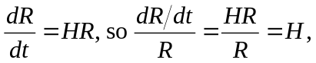 presumed to be the same for all points on the surface. b) For constant 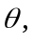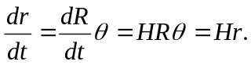 c) See part (a), 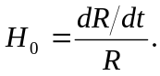 d) The equation 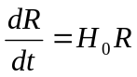 is a differential equation, the solution to which, for constant 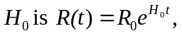where 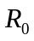 is the value of R at . This equation may be solved by separation of variables, as 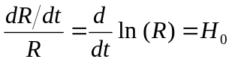 and integrating both sides with respect to time. e) A constant  would mean a constant critical density, which is inconsistent with uniform expansion.

